|  |  |  |  |
| --- | --- | --- | --- |
|  | WITH  UK  [TheraPaw-UK@ClassicPhysiotherapy.co.uk](mailto:TheraPaw-UK@ClassicPhysiotherapy.co.uk)  Tel: 07767455168 OXFORD, UK  **THERAPAW UK CUSTOM CARPAL SUPPORT ORDER/QUOTE FORM 2020** | |  |
|  | |





# **CLINIC INFORMATION** __ **DATE** _______________

# **Vet/Therapist Name:** __

# **Email:** __

# **Phone:** __

# **Clinic Name and Postal Address :** __

**QUOTE and PAYMENT  and  POSTING  INFORMATION  (please  read  carefully)**

**Upon receipt of this form we will assess the pet’s requirements and provide a quote within 2 working days. If you do not receive this please contact as we may not have received the form.**

**The product will  be  fabricated  upon  receipt  of  payment – allow 5 working days after payment for product to be posted via tracked special delivery.**

**We accept  payment via  BANK TRANSFER only. There are no refunds on these custom  orders.**

|  |
| --- |
| **\*\*\*\*\*\*\*\*\*\*\*\*\*\*\*\*\*\*\*\*\*\*\*\*\*\*\*\*\*\*\*\*\*\*\*\*\*\*\*\*\*\*\*\*\*\*\*\*\*\*\*\*\*\*\*\*\*\*\*\*\*\*\*\*\*\*\*\*\*\*\*\*\*\*\*\*\*\*\*\*\*\*\*\*\*\*\*\*\*\*\*\*\*\*\*\*\*\*\*\*\*\*\*\*\*\*\*\*\*\*\*\*\*\*\*\*\*\*\*\*\*\*\*\*\*\*\*\*\*\*\*\*\*\*\*\*\*\*** |

**PATIENT INFORMATION Is this a repeat order for the same device? Yes** __ **No** __

**Pet’s name:**_________________________ **Last name:**___________________ **dog** __ **cat** __ **other** __

**Breed (REQUIRED):** ____________________ **Age (REQUIRED):** _____ **Weight (REQUIRED):** __

**PHOTOS and VIDEO gratefully received in order to better the custom order.**

**Affected limb(s):**  __right fore __ left fore **Date of injury/Onset of Symptoms:** _

**Injury/condition affecting the carpus**: ________________________________________________________

__ congenital __ acute/traumatic __ chronic __ progressive __ degenerative __ not sure

**Type of instability *(check all that apply)*:** __ hyperextension __ palmigrade __ medial laxity __ lateral laxity __ valgus __varus __flexion contracture __ oedema other ____________________________

**If condition is a deformity/deviation, can it be passively manually corrected:** __ yes __no __somewhat

**Other medical issues:** ___

**FABRICATION – Photographs are much appreciated to help design**

**Custom Carpal Support needed for which limb:** __ right fore __ left fore __ both

**Type of support needed *(check one)*:** __ Light *(e.g., light fabric, narrow straps, thin padding)*

__ Moderate *(e.g., medium-weight fabric, wider straps)*

__ Heavy (*e.g.,* *heavy fabric, additional straps, thick padding*)

**Rate degree of movement desired at carpal joint:**

__1 __2 __3 __4 __5 __6 __ 7 __8 __9 __10

almost complete mobility moderate stability **\***complete immobilization

\**for complete immobilization, thermoplastic splinting material is required to mold over carpal support*

**FABRICATION - *continued***

**Are you going to fabricate a thermoplastic splint over the carpalsupport?** __yes __no __not sure

**If “yes”, over what aspect(s) of the limb are you splinting *(check all that apply*)?**

__cranial __caudal __medial __ lateral __not sure

**OTHER REQUESTED MATERIALS *(check all that apply)* – there may be an added cost for these items:**

__thermoplastic sheet - *includes 1 thermoplastic sheet, self-adhesive Velcro hook, splinting instructions*

__nylon support strap(s) - *for additional support or to inhibit movement* *(can be applied/removed as needed)*

**Padding** (this refers to the inner padding material in direct contact with the pet’s limb - please select style)

__self-adhesive foam - *lightweight, water resistant, should be replaced as needed when soiled or flattened*

__sheepskin - *for delicate skin or shaved limb*

__neoprene - *for use in water, UWTM, free swim etc. (Carpal Support MUST be removed when pet completes water activity and dried completely before reapplying; an additional Carpal*

*Support may be warranted for land-based activities)*

__no padding - suitable if required for proprioceptive purposes only

**In what activities will the pet be engaged while wearing the Carpal Support ?**

________________

**How many hours per day will the pet be wearing the Carpal Support?** _____

**MEASUREMENTS**

**Measurements to be taken in Centimetres**   **Is the limb shaved:** __**Yes** __**No**

**Measurements are taken while pet is:** __ **standing, weight bearing/** __ **lying down**

**Measure ONLY the limb requiring Custom Carpal Support**

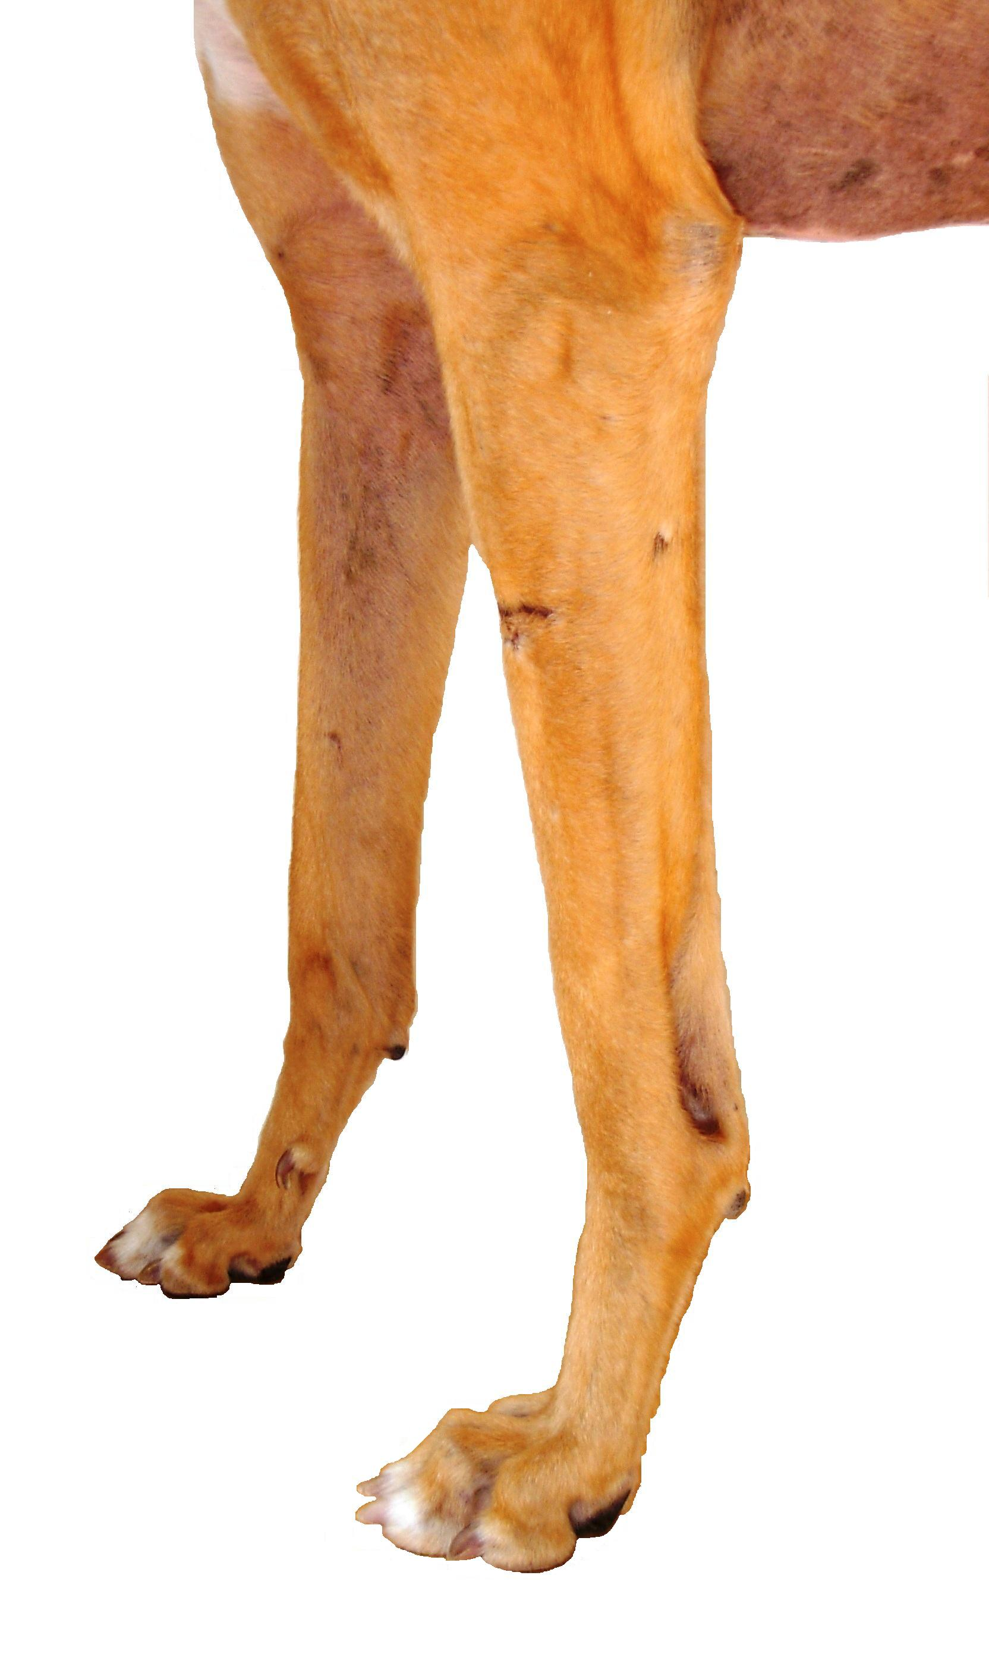

**A** (circumference of limb just above paw) _______Right _______Left

**B** (circumference at mid meta-carpal) _______Right _______Left

**C** (circumference at carpal joint) _______Right _______Left

**H**

**D** (circumference just above carpal joint) _______Right _______Left

**E**

**E** (circumference at mid-radius/ulnar) _______Right _______Left

**G**

**F** (palmar height - main footpad to accessory pad) _______Right _______Left

**D**

**G** (caudal height - accessory pad to mid-radius/ulna **E**) ______Right _______Left

**H** (caudal height - accessory pad to point of elbow) _______Right _______Left

**C**

**If there is a wound or abrasion on the limb please indicate its location**

**B**

**by description/marking diagram -🡪**

**A If there is a wound or abrasion on the limb please indicate its location by description/marking diagram -🡪**

**F**

_______________________________________________________________________________________

**Please email to TheraPaw-UK@ClassicPhysiotherapy.co.uk**

**We will contact you within 2 business days of receipt of this order.**

**If you do not hear from us, contact us at 07767455168 or resend your order, as we did not receive it.**